Data Visualization with Pandas
Pandas is a powerful open-source data analysis and manipulation library for Python. The library is particularly well-suited for handling labeled data such as tables with rows and columns. Pandas allows to create various graphs directly from your data using built-in functions.

Key Features
- Variety of Plot Types: Pandas supports various plot types including line plots, bar plots, histograms, box plots, and scatter plots.
- Customization: Users can customize plots by adding titles, labels, and styling enhancing the readability of the visualizations.
- Handling of Missing Data: Pandas efficiently handles missing data ensuring that visualizations accurately represent the dataset without errors.
- Integration with Matplotlib: Pandas integrates with Matplotlib that allow users to create a wide range of static, animated, and interactive plots.

Importing necessary libraries and data files
Once Pandas is installed, import the required libraries and load your data Sample CSV files df1 and df2 used:
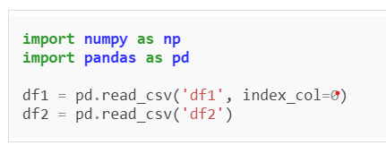
Explanation:
- pd.read_csv('df1', index_col=0) loads df1.csv and sets the first column as the index.
- pd.read_csv('df2') loads df2.csv with default indexing.

Pandas DataFrame Plots
Pandas provides several built-in plotting functions to create various types of charts mainly focused on statistical data. These plots help visualize trends, distributions, and relationships within the data.

Pandas DataFrame Techniques
- Line plots
- Bar plots
- Scatter plots
- Histograms
- Box plots
- Line plots with Different line
- Kernel Density Estimation pots

- Line Plots using Pandas DataFrame
A line plot is a graph that shows the frequency of data along a number line. It is best to use a line plot when the data is time series. It can be created using Dataframe.plot() function.
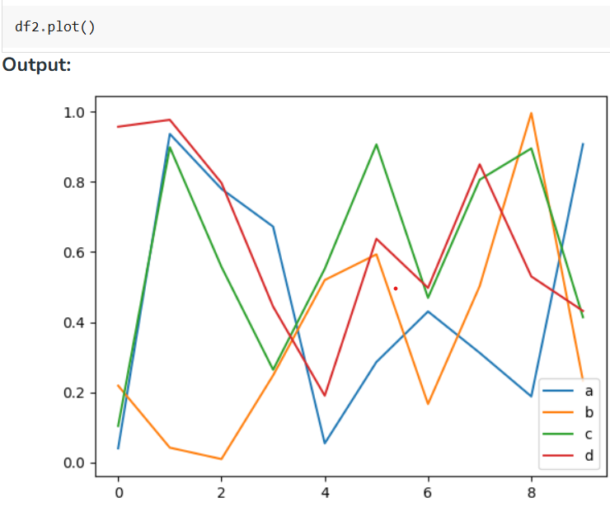

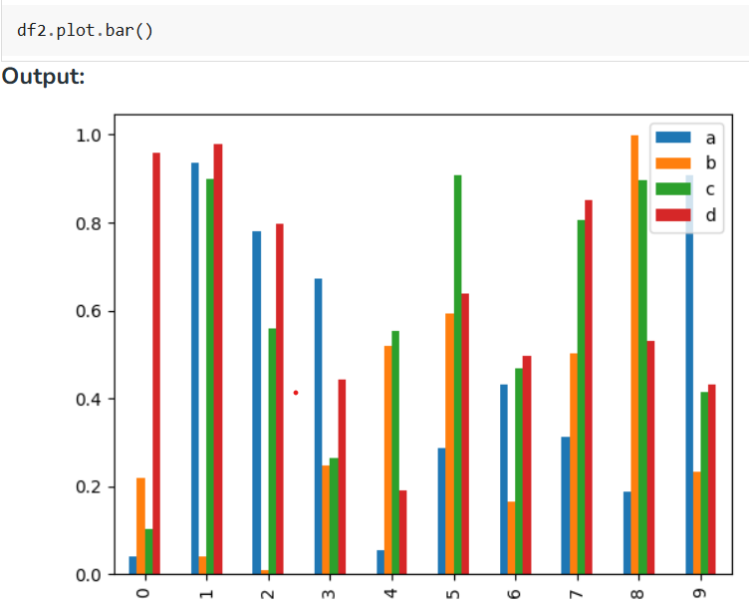
2. Bar Plots using Pandas DataFrame
A bar chart presents categorical data with rectangular bars with heights or lengths proportional to the values that they represent. The bars can be plotted vertically or horizontally with DataFrame.plot.bar() function.
3. Scatter Plot using Pandas DataFrame
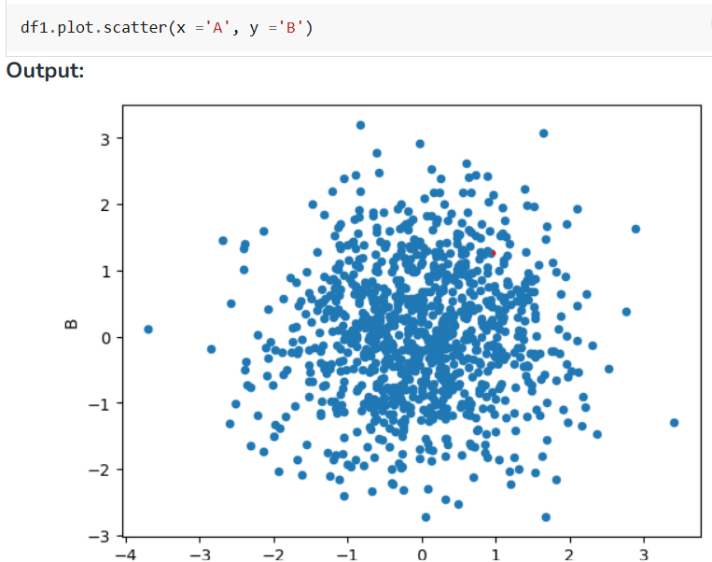
Scatter plots are used when you want to show the relationship

between two variables. They are also called correlation and can be created using DataFrame.plot.scatter() function.

4. Histogram Plot using Pandas DataFrame
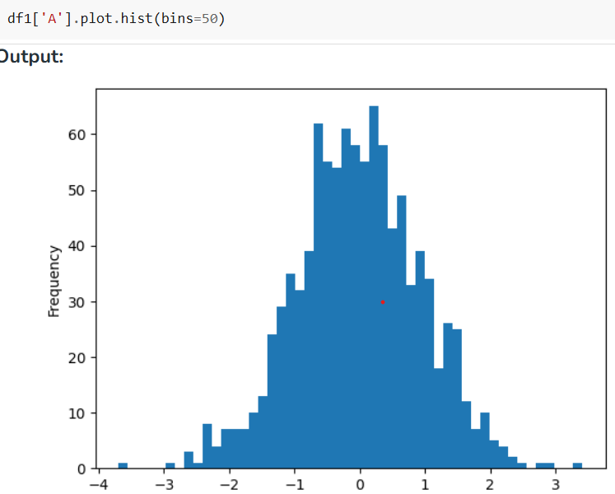
Histograms help visualize the distribution of data by grouping values

into bins. Pandas use DataFrame.plot.hist() function to plot histogram.

5. Box Plots using Pandas DataFrame
A box plot displays the distribution of data, showing the median, quartiles, and outliers. we can use DataFrame.plot.box() function or DataFrame.boxplot() to create it.

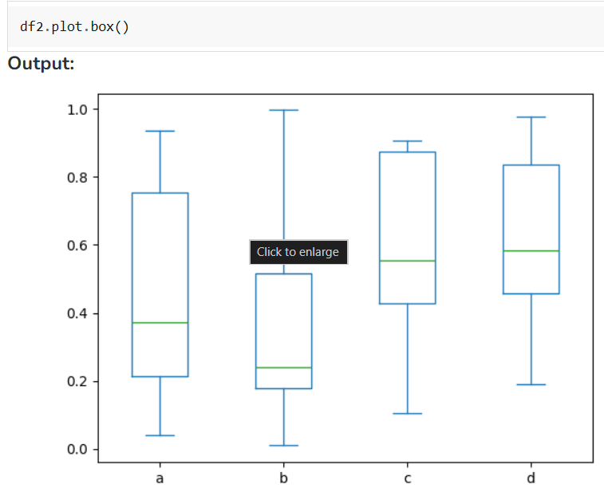

6. Line Plot with Different Line
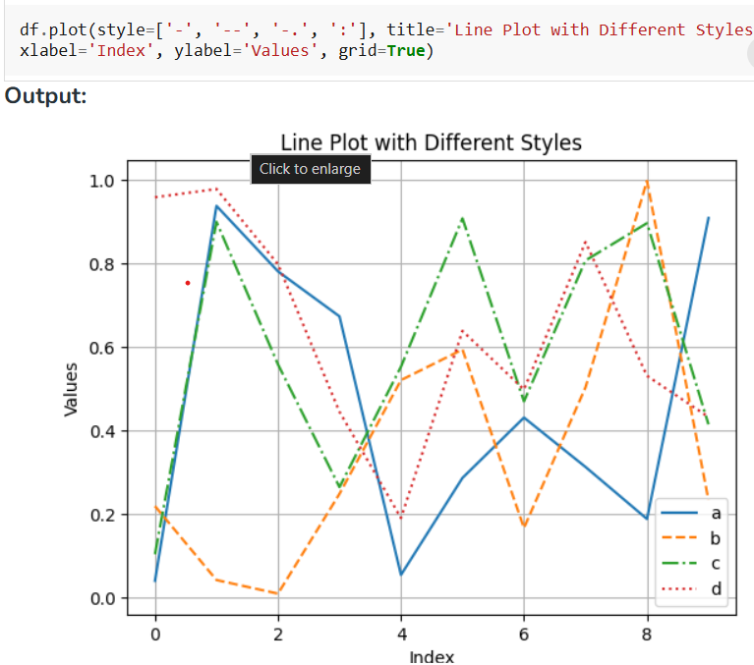
If you want to differentiate between the two lines visually you can

change the line style (e.g., solid line, dashed line) with the help of pandas.

7. Kernel Density Estimation plot (KDE)
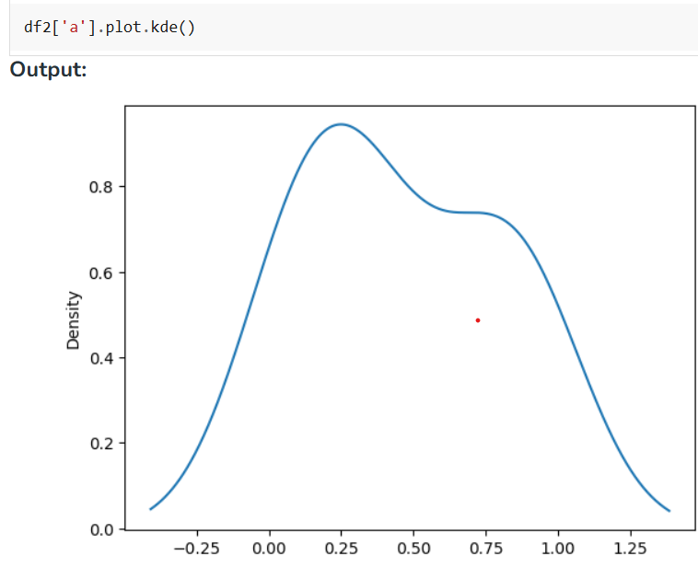
KDE (Kernel Density Estimation) creates a smooth curve to show the shape of data by using the df.plot.kde() function. It's useful for

visualizing data patterns and simulating new data based on real examples.

Data Visualization with Seaborn
Seaborn is an amazing visualization library for statistical graphics plotting in Python. It provides beautiful default styles and color palettes to make statistical plots more attractive. It is built on top matplotlib library and is also closely integrated with the data structures from pandas.
Keys Features:
1. Seaborn is a statistical plotting library.
- It has beautiful default styles
- It also is designed to work very well with Pandas dataframe objects.
- Seaborn works easily with dataframes and the Pandas library. The graphs created can also be customized easily.

Creating Plots with Seaborn

Seaborn makes it easy to create clear and informative statistical plots with just a few lines of code. It offers built-in themes, color palettes, and functions tailored for different types of data.

Seaborn Technique
- Line plot
- Scatter plot
- Box plot
- Violin plot
- Bar plot
- Point plot

1. Line plot

A line plot shows the relationship between two numeric variables, often over time. It can also compare multiple groups using different lines.

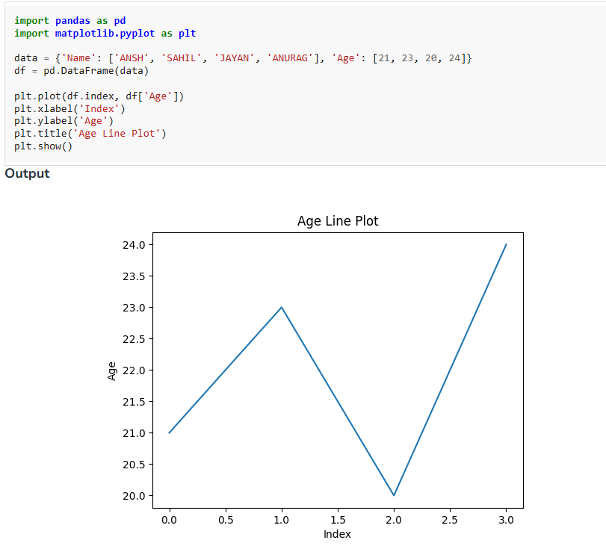

2. Scatter Plot
Scatter plot are used to visualize the relationship between two numerical variables. They help identify correlations or patterns. It can draw a two-dimensional graph.

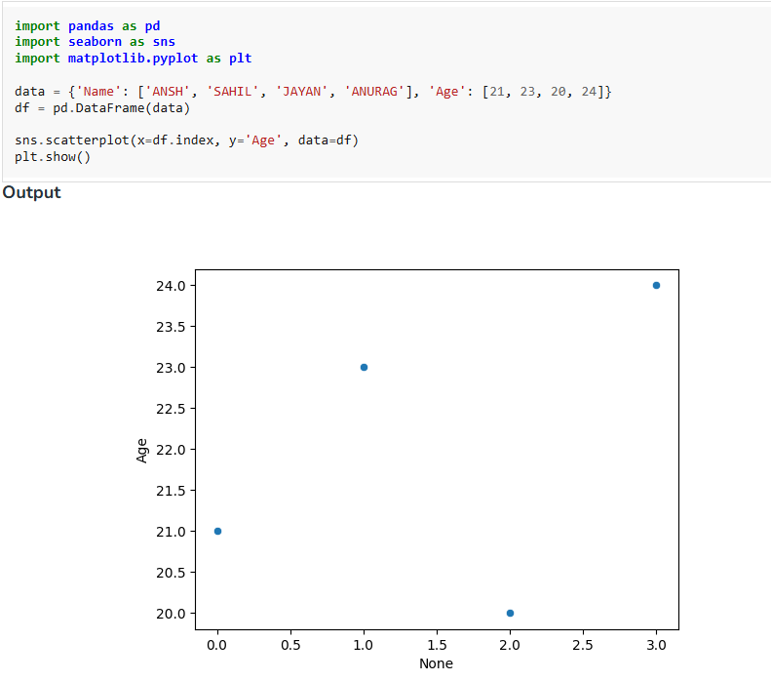
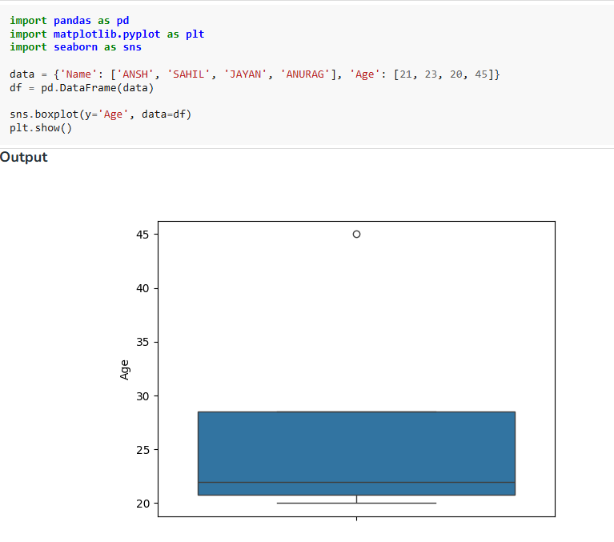
3. Box plot
A box plot is the visual representation of the depicting groups of numerical data with their quartiles against continuous/categorical data.
It consists of 5 key statistics: Minimum ,First Quartile or 25% , Median (Second Quartile) or 50%, Third Quartile or 75% and Maximum
4. Violin Plot
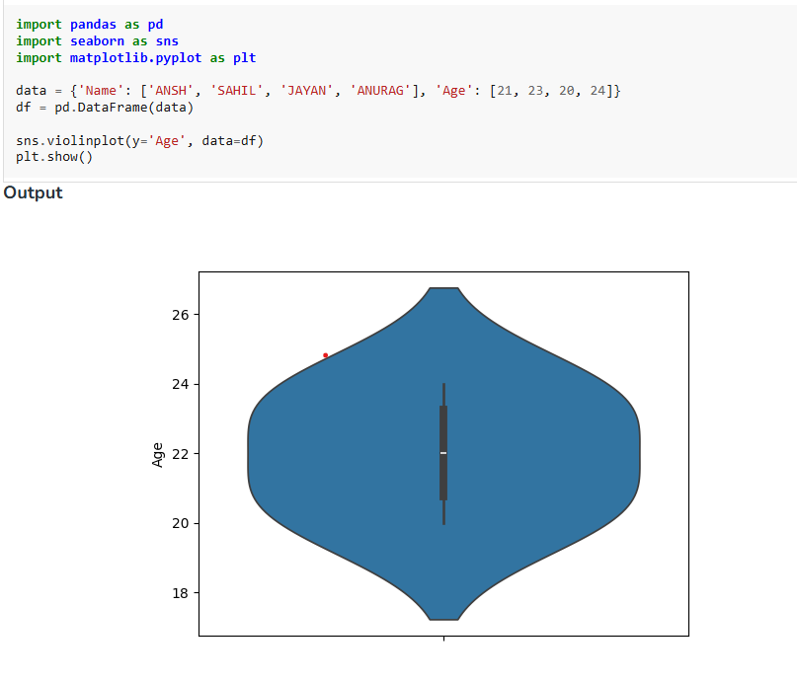
A violin plot is similar to a boxplot. It shows several quantitative data across one or more categorical variables such that those distributions can be compared.

5. Bar plot
Bar plot represents an estimate of central tendency for a numeric variable with the height of each rectangle and provides some indication of the uncertainty around that estimate using error bars.
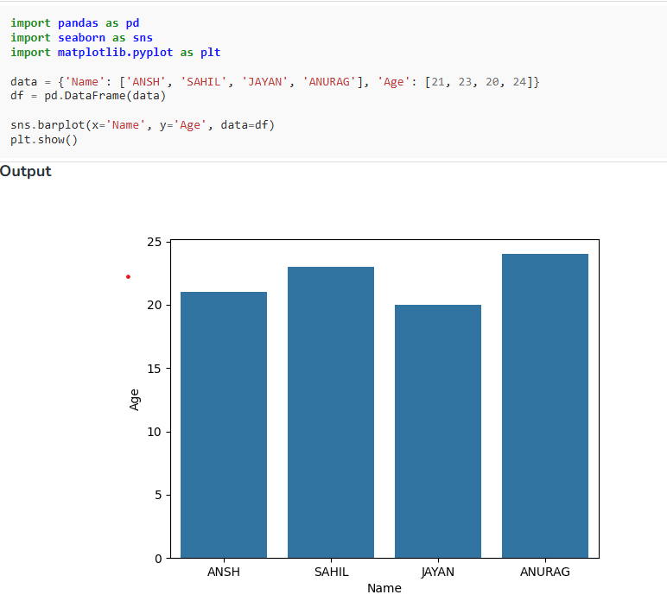

6. Point plot
Point plot show point estimates and confidence intervals using scatter glyphs which represents the central tendency of a numeric variable.
